MeshForge candidate review
Verification token
Draft for human review. This candidate remains review required. Report approval permits document handoff only; it does not approve the model for production or publication.
Evidence date: 2026-10-10 | Report generated: 2026-10-17 | Profile: Preview

Source and candidate
Controlled source  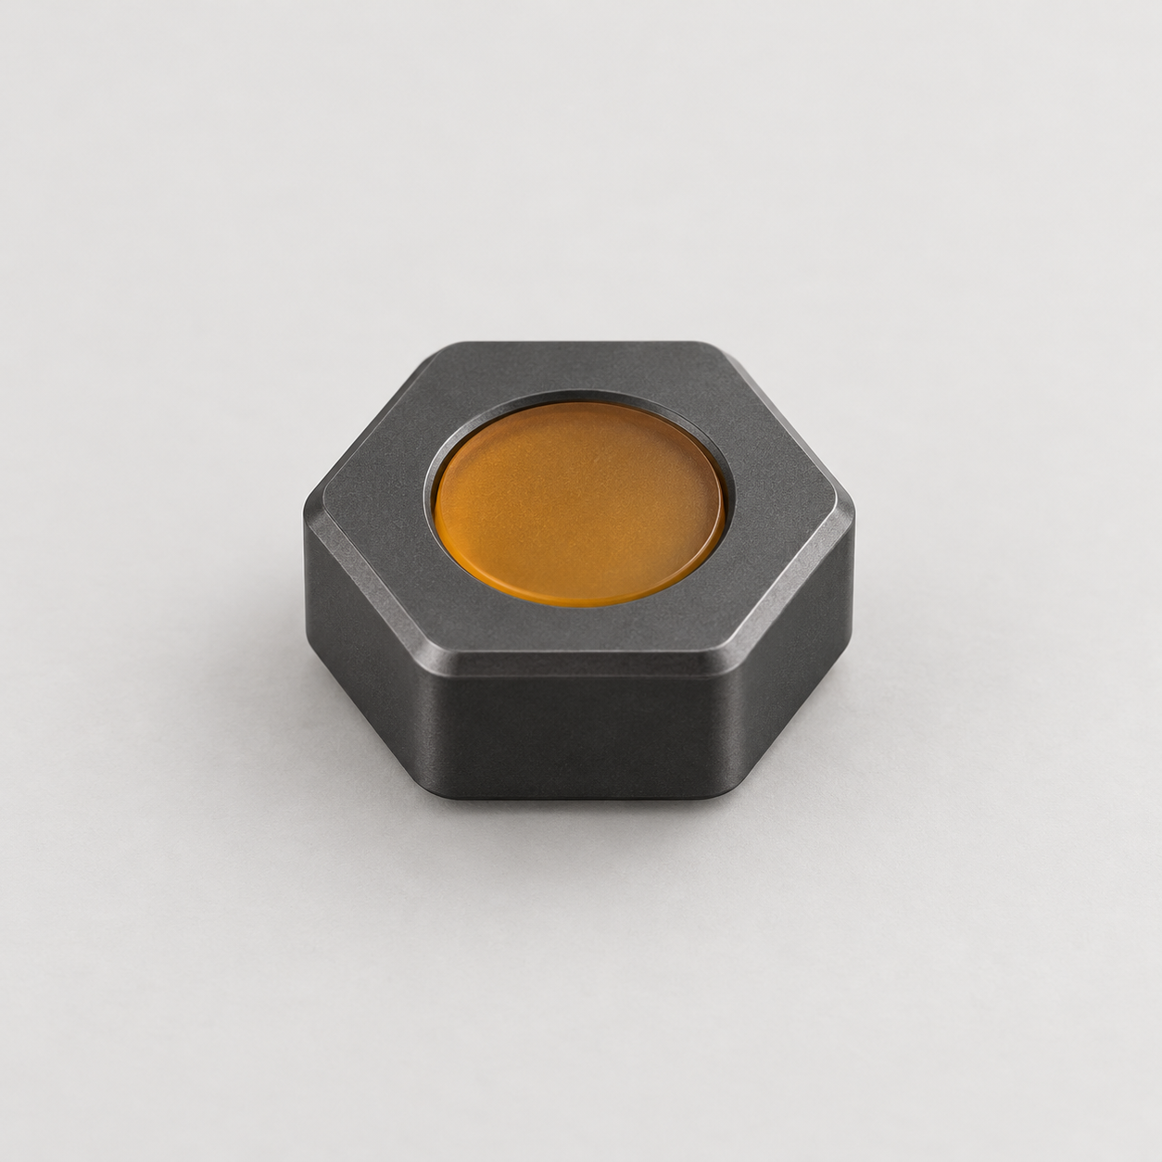  Full silhouette, neutral light, isolated object. | Generated candidate  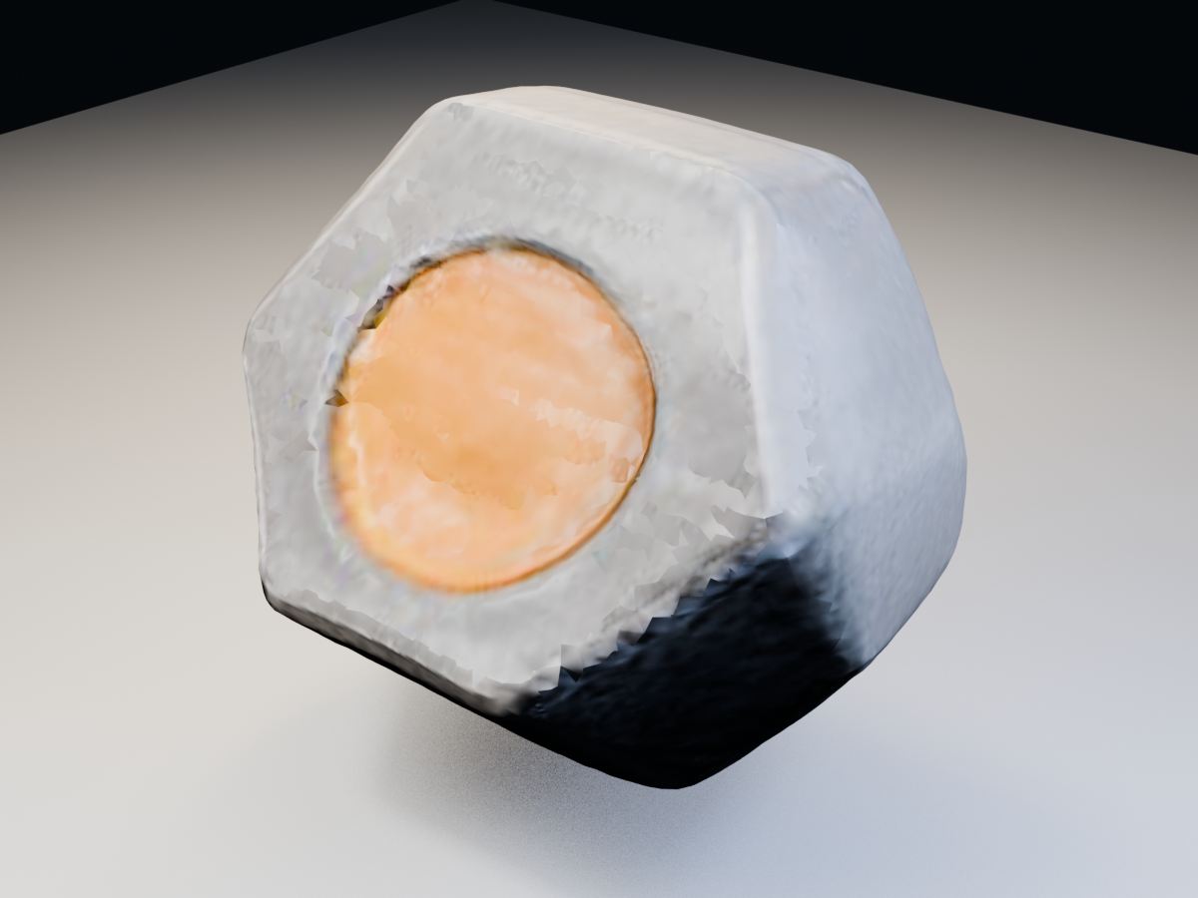  Recognizable silhouette and inset, with softened material detail and no separable body or inset roles.

Recorded measurements
Measure | Recorded value
Runtime | 80.76 sec
Triangles | 35,796
Components | 1 logical / 222 raw
Topology edges | 0 logical / 5,040 raw
Status | Review required

Review decision
The basic form survives, including the inset. After attribute splits are welded, the candidate is one logical manifold component. Its softened form, fused material role, and missing semantic labels still make it a visual blockout.
Decision pending. Check: Does the candidate preserve the hexagonal body, shallow top inset, and visible thickness without inventing an unstable underside?
Provenance: benchmark summary and paired assets copied into this package with SHA256 checksums. Measurements are reproduced from the recorded benchmark; no new generation or verifier run is claimed.

